Team Charter

Team Name
Your team name: EventCrafters
Logo:
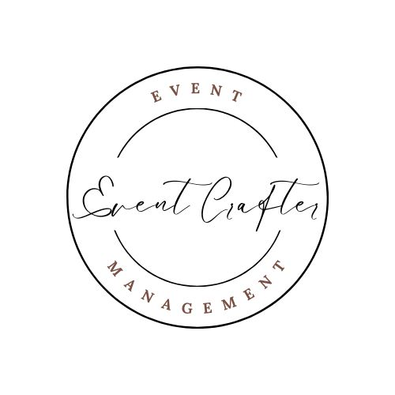

Team Members
List team member names and contact information
Joyekeneth Gamit – jgamit7181@conestogac.on.ca
Dhwani Bhavsar – dbhavsar7285@conestogac.on.ca
Navpreet Navpreet - navpreet3943@conestogac.on.ca

Member Roles
List the team member(s) who will work on each aspect of the project in the table below:

Project Management
Team leadership | Joyekeneth
Project planning | Joyekeneth,Dhwani,Navpreet
Project record-keeping | Joyekeneth,Dhwani,Navpreet
Analysis, Design and Documentation
Interacting with clients
Diagramming and documenting client requirements | Joyekeneth,Dhwani,Navpreet
Diagramming and documenting overall design | Joyekeneth,Dhwani
Technical documentation | Joyekeneth,Dhwani
Client documentation | Navpreet
Web Development
Creating web graphics | Joyekeneth
Web site design | Dhwani
Web page design | Navpreet
Web programming | Joyekeneth,Dhwani
Interactive testing | Dhwani
Business Layer Development
Class design | Joyekeneth,Dhwani,Navpreet
Business programming | Joyekeneth,Navpreet
Technical / lower-level programming | Dhwani
Unit and integration testing | Joyekeneth
Database Development
Database design | Joyekeneth
SQL/LINQ Development | Dhwani
Other
Report development | Joyekeneth,Dhwani,Navpreet
Installer development | Joyekeneth,Dhwani,Navpreet

Expectations

Document the team’s expectations e.g. equal sharing of work, attending all meetings, creating deliverables on time, etc.
• Attendance at All Scheduled Meetings: Members of the team are required to show up for all scheduled meetings, including regular team meetings, project updates, and any unscheduled get-togethers that the team captain or another team member calls.
• Active Participation: During meetings, actively participate in the conversation and decision-making process. Ask questions, voice your thoughts, and offer helpful feedback to ensure that the team reaches logical decisions.
• Equitable Work Distribution: Every team member must participate equally to the responsibilities and tasks that are delegated to them. This means distributing the work equally among individuals based on their skill sets and areas of expertise.
• Productivity at Work: Strive for excellence in all undertakings and results. Make sure your work is error-free of the highest caliber and meets the team's standards and objectives.
• Meeting Deadlines: Finish assignments and duties for projects by the dates that the team has decided upon. Inform the team as soon as you suspect there might be issues meeting the deadline, and then collaborate to find a solution.
By adhering to these criteria, we will establish a cohesive and productive team environment, ensuring our success in the EventCrafters Project. Together, let's accomplish and even surpass our goals.

Consequences

Document how the team will react if expectations are not met.
1. Determine the Root Cause: The team will work together to identify the main cause of the unmet expectation. This may involve arguing the origins of the issue and gathering relevant information.
2. Collaborative problem-solving: To address the issue, the group will engage in cooperative problem-solving. This could involve coming up with a strategy, receiving team input, and talking about possible fixes.
3. Establish Who Is Responsible: Following the discovery of a workable solution, the team will assign roles for executing the required corrective actions. This ensures responsibility and ownership for the settlement procedure.
4. Record-keeping: Talks, decisions, and actions pertaining to unfulfilled expectations will all be documented for later reference. This documentation facilitates the maintenance of transparency and accountability.

Agreement

Each team member must sign the charter. The Team Charter can be revised at any time during the project with the consent of all team members.
Joyekeneth Gamit – JG
Dhwani Bhavsar – DB
Navpreet Navpreet - NN

